Reading 2D Lists

Look at this code:
clubs = [["Art", 12], ["Chess", 18], ["Code", 15]]
row = int(input("Club row 0 to 2: "))
print("Record:", clubs[row])
print("Club:", clubs[row][0])
print("Members:", clubs[row][1])

What do you think this code will display?
Click or tap here to enter text.

Run the code. Compare the result with your prediction:
Click or tap here to enter text.

Let’s investigate! Answer the questions below:
- Why does clubs[1][0] select a field but clubs[1] selects a complete row?
Click or tap here to enter text.

- What happens if the selected row position does not exist?
Click or tap here to enter text.

- Why must every row keep the same field order for column 1 to mean members?
Click or tap here to enter text.

- If you enter row 1, what record, club and member count are displayed?
Click or tap here to enter text.

Reading 2D Lists

Look at this code:
clubs = [["Art", 12], ["Chess", 18], ["Code", 15]]
row = int(input("Club row 0 to 2: "))
print("Record:", clubs[row])
print("Club:", clubs[row][0])
print("Members:", clubs[row][1])

Use the code above to help you. After completing each challenge below, run your program to test that it works correctly. Save each completed challenge program in a new file.

Programming Challenges

Challenge 1
Select row 2. The output must identify Code and 15 from the same record.
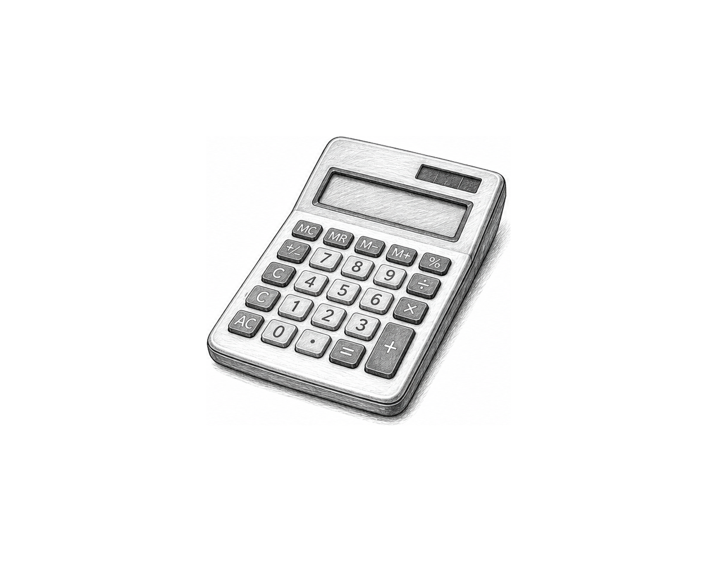

Challenge 2
Traverse every row and display each club name followed by its member count. Do not print the row brackets.

Challenge 3
Create a three-row timetable. Each row stores a subject and room number. Ask for a valid row, then display a sentence containing both selected fields. Also display every subject name using a loop.

Reading 2D Lists

Fix the code!

This code has errors! Look closely at the code to find the problems:

clubs = [["Art", 12], ["Chess", 18], ["Code", 15]
row = 1
print("Members:", clubs[row, 1])

Rewrite the whole program in the box below with fixes to the errors.
Click or tap here to enter text.

After you are confident that you fixed all the errors, copy the code from the box and run it.

Did it work correctly on your first try? Did you find all the errors?
Click or tap here to enter text.

